**Introduction to Database**

**Phase 1**

**Project:** Games Rental System

**Team Members**

|  |  |
| --- | --- |
| Name | ID |
| Omar Hesham | 20236067 |
| Abdelrahman Mohamed | 20236055 |
| Omar Essam | 20236064 |
| Seif Nagy | 20236048 |
| Abdelrahman Haitham | 20237006 |
| Omar mahrous | 20236065 |

**Entities:**

1. **ADMIN** o AdminID (PK) o Username o Password o FullName o Email o Phone
2. **CLIENT** o ClientID (PK) o Username o Password o FullName o Email o Phone

o Address

# 3. VENDOR

* VendorID (PK) o VendorName
* ContactInfo

4. **GAME** o GameID (PK) o Title o ReleaseYear o Genre

o Price

# 5. RENTAL

o RentalID (PK) o RentalDate o ReturnDate o Status

6. **REVIEW** (Weak Entity) o ReviewID (PK) o Rating o Comment o ReviewDate

ERD:

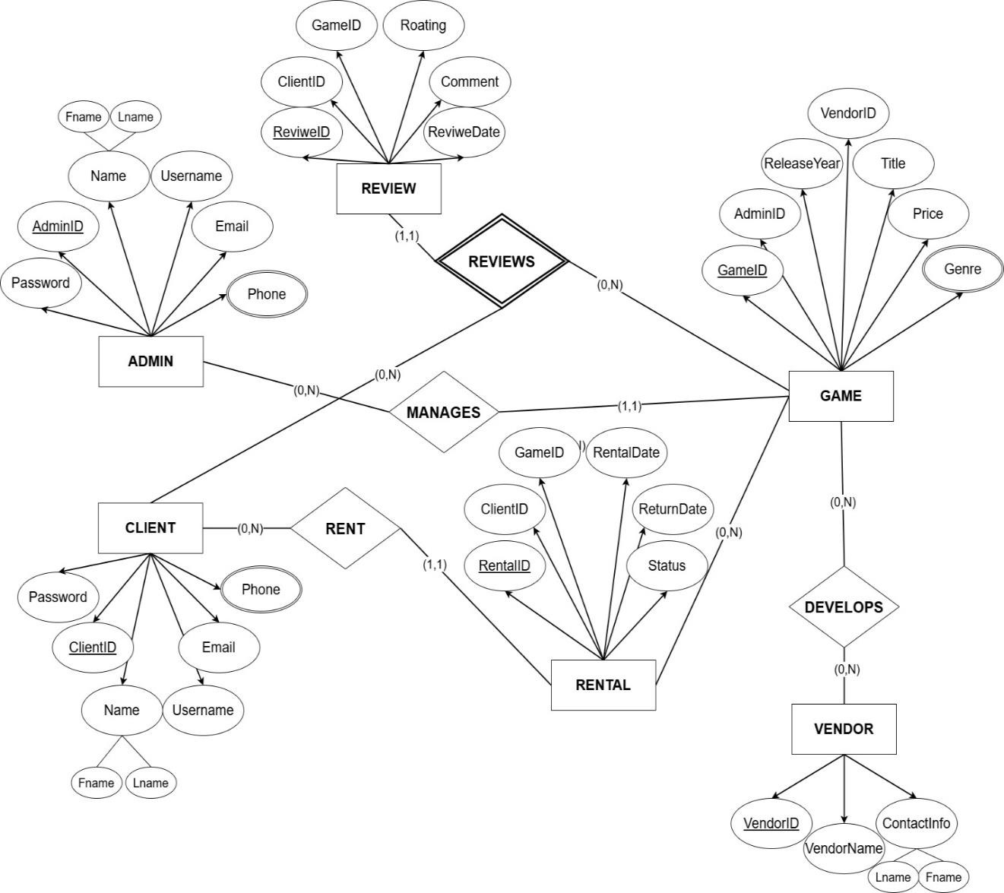

**Functional Requirements:**

# 1. User Management

* The system must allow new users (Admins and Clients) to sign up by providing name, username, email, phone, and password.
* The system must allow users to update their personal details.

# 2. Game Management

* Only Admins can add new games with details like title, genre, release year, vendor, and price.
* The system must automatically update rental status based on return activity.
* Admins must be able to update game details.
* The system must support browsing all games.
* The system must allow users to filter/search for games based on year, vendor, genre (category), or other attributes.

# 3. Rental Operations

* Clients must be able to rent available games.
* Clients must be able to return rented games.
* The system must maintain rental history, including rental date, return date, and status.
* The system must be able to calculate the number of rentals per client within a specified date range.

# 4. Review System

* Clients must be able to submit reviews for rented games, including a rating, comment, and review date.
* The system must calculate a "popularity score" based on number of renters and average rating

# 5. Admin Operations

* Admins must be able to manage rentals.
* Admins must monitor game activity (which games are most or least rented).
* Admins must be able to generate a report showing the most/Least rented games, sorted by renter count and average rating.

# 6. Vendor Management

* Vendors must be linked to the games they develop.
* The system must maintain vendor details (name, contact info).
* The system must track which games were rented and allow joining this data with the corresponding vendor.
* The system must be able to count how many times games from each vendor were rented in a given month.
* The system must generate a list of vendors whose games had no rental entries in the past month.
* Admins must be able to generate a yearly report of vendors who did or did not contribute new games.

**7. Search and Filter**

• Clients must be able to search games by keywords (title, genre).

# • Clients can apply filters such as: Genre, Release Year, Price Range, Vendor Game

# 

